1. **ER diagram creation site :** draw.io.
2. **User contact ER diagram.**

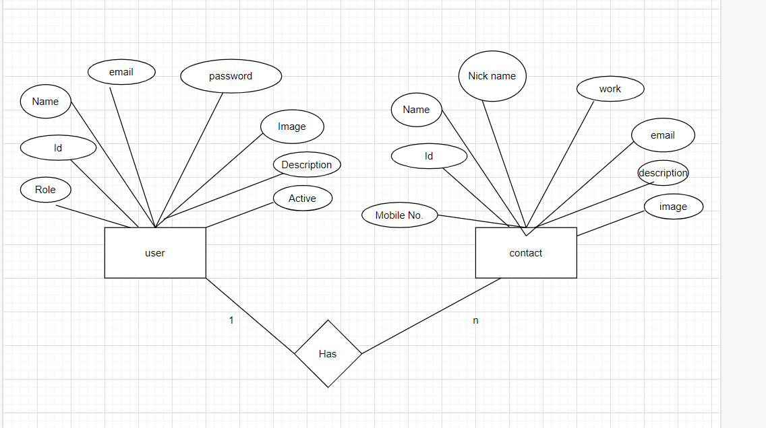

1. **Flat icon site for icon.**
2. **Login using spring security.**
3. **Provide the implementation of UserDeatils interface.**
4. **Provide the implementation of UserDeatilsService interface.**
5. **Create simple class which extends WebSecurityConfigurerAdapterClass.**